**Assignment 5:**  **Materialized Views and Query Rewriting**

**1. Create Materialized Views**

***Shipment transactions for year 2011***

**Materialized view**

CREATE MATERIALIZED VIEW MDV1

BUILD IMMEDIATE

REFRESH COMPLETE ON DEMAND

AS

SELECT i.custvendorkey, d.datekey,

SUM(i.ExtCost) as Sum_Extended_Cost,

SUM(i.Quantity)as Sum_Quantity,

COUNT(*)as Number_Of_Inventory_Trans

FROM mmannino.date_dim d,mmannino.inventory_fact i

WHERE d.datekey = i.datekey

AND i.Transtypekey = 5

AND d.CALYEAR = 2011

GROUP BY i.custvendorkey, d.datekey;

***Shipment transactions for year 2012***

**Materialized view**

CREATE MATERIALIZED VIEW MDV2

BUILD IMMEDIATE

REFRESH COMPLETE ON DEMAND

AS

SELECT i.custvendorkey, d.datekey,

SUM(i.ExtCost) as Sum_Extended_Cost,

SUM(i.Quantity)as Sum_Quantity,

COUNT(*)as Number_Of_Inventory_Trans

FROM mmannino.date_dim d,mmannino.inventory_fact i

WHERE d.datekey = i.datekey

AND i.Transtypekey = 5

AND d.CALYEAR = 2012

GROUP BY i.custvendorkey, d.datekey;

**Rewritten Query:**

SELECT d.calmonth,c.addrcatcode1,sum(m.Sum_Extended_Cost), sum(m.Sum_Quantity)

FROM MDV1 m, mmannino.cust_vendor_dim c, mmannino.date_dim d

WHERE m.custvendorkey = c.custvendorkey

AND d.datekey = m.datekey

GROUP BY CUBE (d.calmonth,c.addrcatcode1);

**Output:**

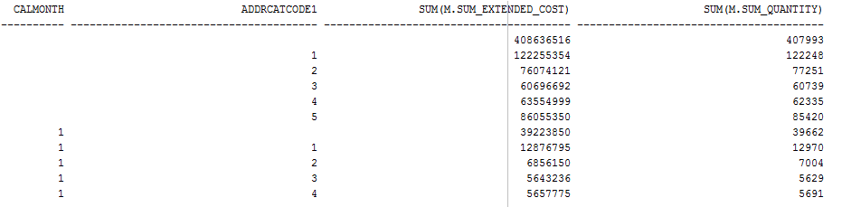

**Rewritten Query:**

SELECT calquarter,zip,name,sum(SExCo),sum(NofItrx)

FROM

(

SELECT d.calquarter,c.zip,c.name,

SUM(m.Sum_Extended_Cost) as SExCo,

SUM(m.Number_Of_Inventory_Trans) AS NofItrx

FROM MDV1 m, mmannino.cust_vendor_dim c, mmannino.date_dim d

WHERE m.custvendorkey = c.custvendorkey

AND d.datekey = m.datekey

GROUP BY d.calquarter,c.zip, c.name

UNION

SELECT d2.calquarter,c2.zip,c2.name,

SUM(m2.Sum_Extended_Cost) as SExCo,

SUM(m2.Number_Of_Inventory_Trans) AS NofItrx

FROM MDV2 m2, mmannino.cust_vendor_dim c2, mmannino.date_dim d2

WHERE m2.custvendorkey = c2.custvendorkey

AND d2.datekey = m2.datekey

GROUP BY d2.calquarter,c2.zip, c2.name

)

GROUP BY CUBE(calquarter,zip, name);

**Output:**

